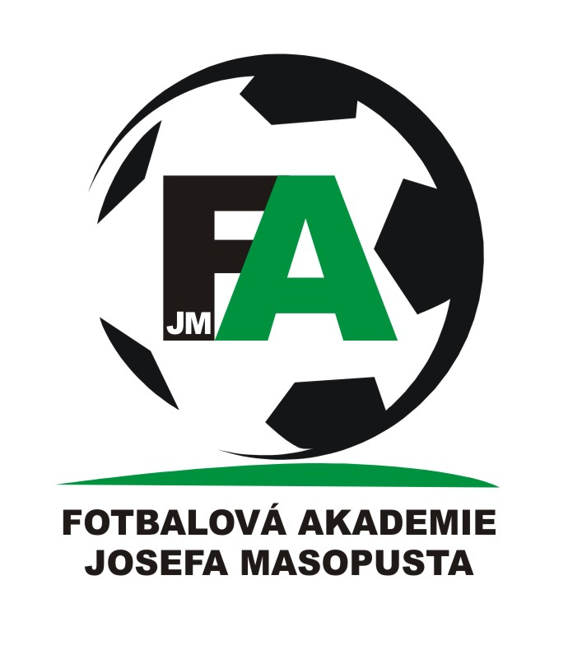
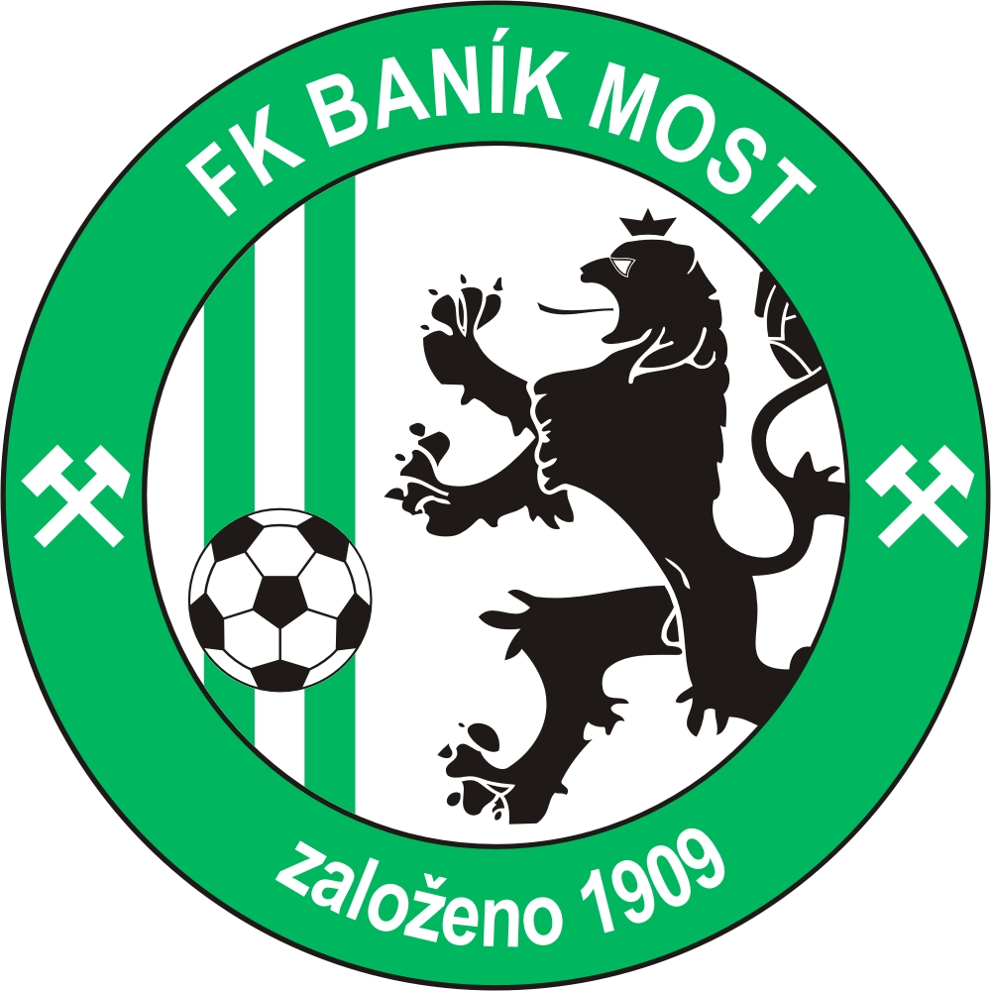

kategorie 2006 halový turnaj 19. 1. 2013

 | čas | sk | Domácí | Hosté | skóre
1 | 8:30 | 1-6 | fk baník most zelení | fk baník most bílí
2 | 8:47 | 2–5 | fš most | fk louny
3 | 9:04 | 3–4 | sk forward one | fk tatran kadaň
4 | 9:21 | 1–2 | fk baník most zelení | fš most
5 | 9:38 | 6–4 | fk baník most bílí | fk tatran kadaň
6 | 9:55 | 5–3 | fk louny | sk forward one
7 | 10:12 | 2–6 | fš most | fk baník most bílí
8 | 10:29 | 3–1 | sk forward one | fk baník most zelení
9 | 10:46 | 4–5 | fk tatran kadaň | fk louny
10 | 11:03 | 2–3 | fš most | sk forward one
11 | 11:20 | 6–5 | fk baník most bílí | fk louny
12 | 11:37 | 1–4 | fk baník most zelení | fk tatran kadaň
13 | 11:54 | 3–6 | sk forward one | fk baník most bílí
14 | 12:11 | 4–2 | fk tatran kadaň | fš most
15 | 12:28 | 5-1 | fk louny | fk baník most zelení

fk baník most bílí | fk louny | fk tatran kadaň | sk forward one | fš most | fk baník most zelení | mOST  2006
 |  |  |  |  |  | fk baník most zelení
 |  |  |  |  |  | fš most
 |  |  |  |  |  | sk forward one
 |  |  |  |  |  | fk tatran kadaň
 |  |  |  |  |  | fk louny
 |  |  |  |  |  | fk baník most bílí
 |  |  |  |  |  | SKÓRE
 |  |  |  |  |  | BODY
 |  |  |  |  |  | POřADí

